



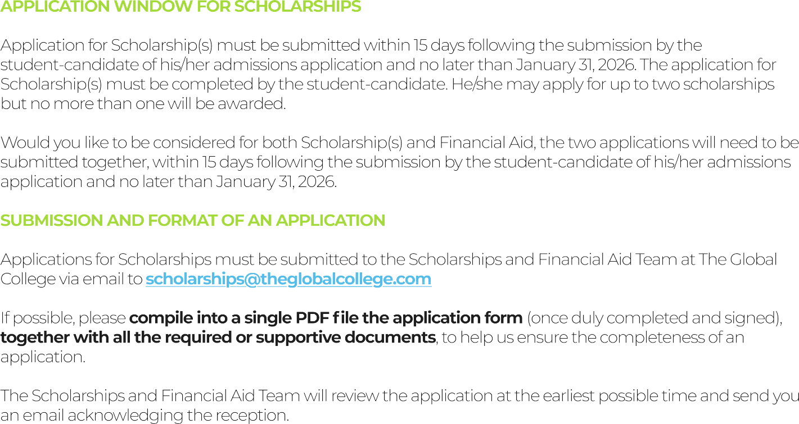









✔

✔







■



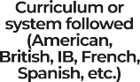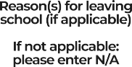



Nagarjuna

Vidyaniketan

Bengaluru,

India

CBSE

8,9

N/A

Daffodils

Foundation for learning

Bengaluru,

India

CBSE

7

Had to shift to

a new house

Sri

Taralabalu Jagatguru

Davangere,

India

CBSE

LKG,UKG,1-6t

h

total 8 years

Shifted to

Bengaluru







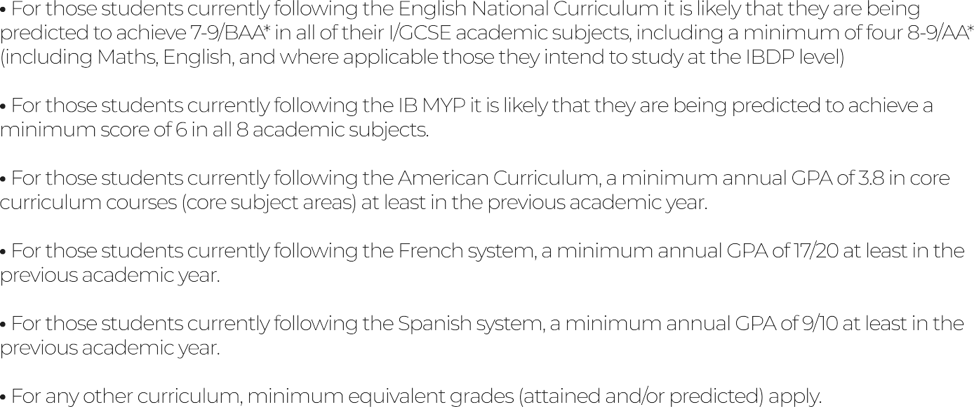













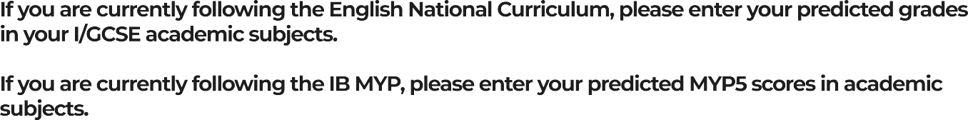





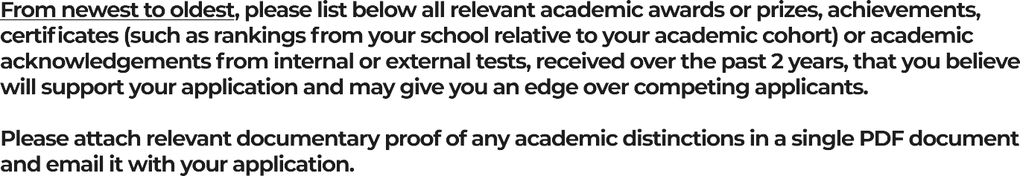

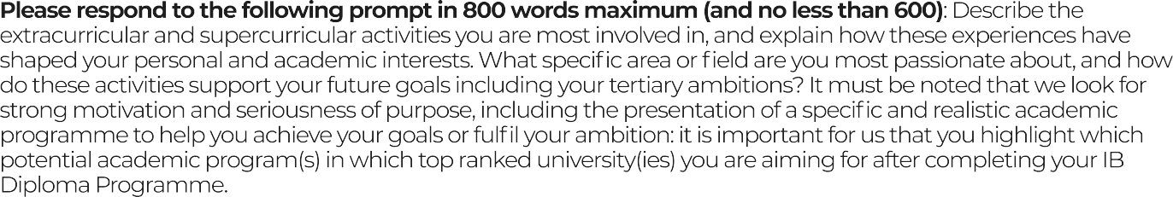



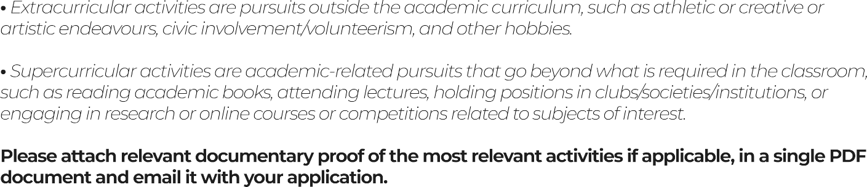







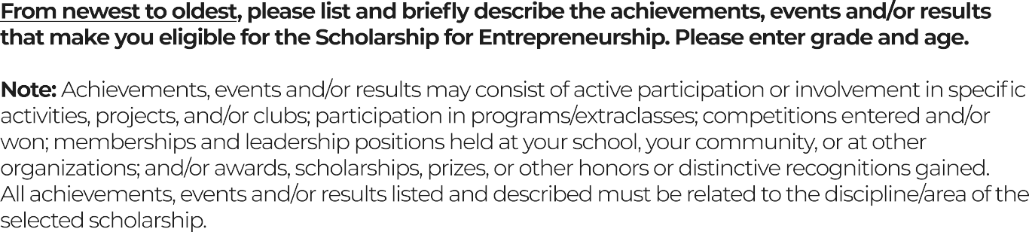





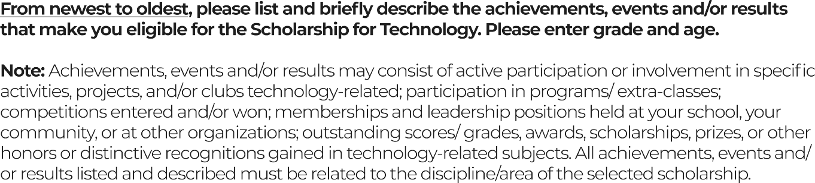

Made an app for school.

8th

13

Built a platform for Government Employee’s

Organisation

9th

14

Developed many coding projects with

html,python,js,xml,css over 50 projects

8th-present

13-15



Girls Code Global Campaign

10th

14



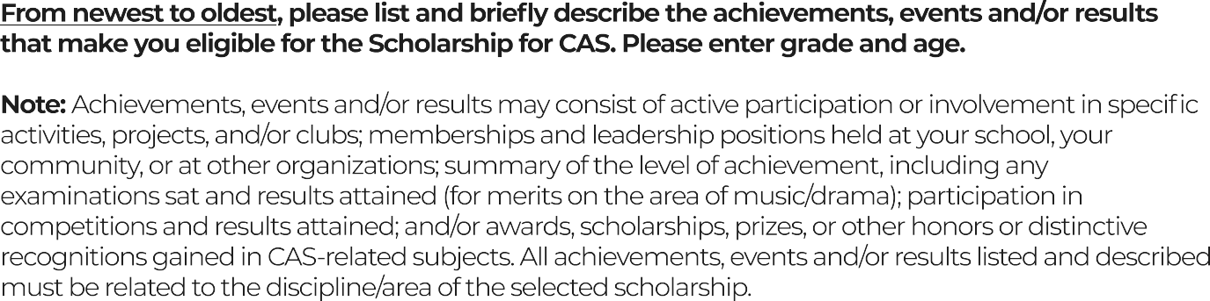



|  |  |  |
| --- | --- | --- |
| Published Author (Multiple Books) | 8th - 9th | 13-14 |
| Raised 10k inr in an event called joy of sharing by selling Pani Puri (Popular Indian street food) | 7th | 12 |
| Guest of Honour at literary fest at Novus school was invited by the director of the school. | 8th | 13 |
| U-Reporter | 10th | 15 |
| MUN Conference: 7 total  6-delegate 1-chair won verbal mentions, special | 9th - 10th | 14 |



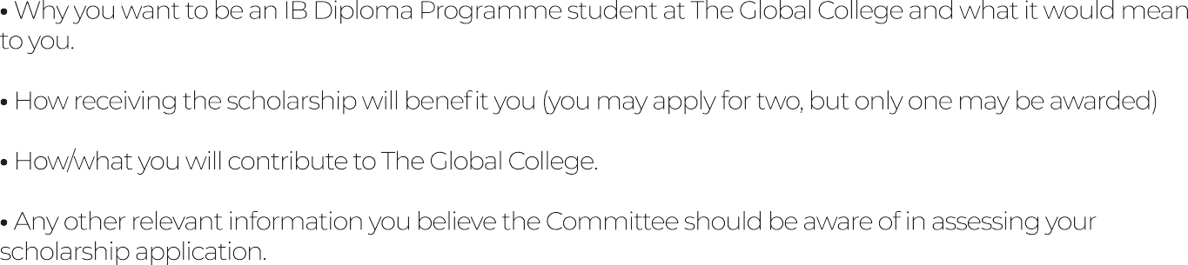

I really want to join The Global College as an IB Diploma Programme student because I feel like it’s a place where I can actually explore my interests and push myself to learn in a way that feels real and meaningful. I love how the IB is about thinking deeply, asking questions, and connecting what we learn to the world around us. For me, it’s not just about getting good grades, it’s about growing as a person, learning how to take on challenges, and discovering what I’m really capable of.

Getting this scholarship would mean so much to me. It would make it possible for me to focus completely on school, projects, and other activities without worrying about financial things. It’s not just money, it’s support that would let me give my best, try new ideas, and get fully involved in everything The Global College offers. It would also motivate me even more to make the most of the opportunities and contribute to the school community.

I think I can really contribute to The Global College because I like taking initiative and helping others learn. I’ve done projects where I taught coding to younger kids, led research, and worked with friends to create ideas that actually make a difference. I want to bring that energy to school, whether it’s helping classmates, starting projects, or participating in competitions and community activities. I like working with others and sharing ideas, and I think I can make the school a more creative and fun place to learn.

I also want the Committee to know that I’m curious, determined, and ready to work hard. I’m someone who doesn’t give up easily, and I love learning new things and trying out challenges, even if they seem difficult at first. Getting into The Global College would be an amazing opportunity to grow, contribute, and be part of a community where I can learn, help, and make a difference.





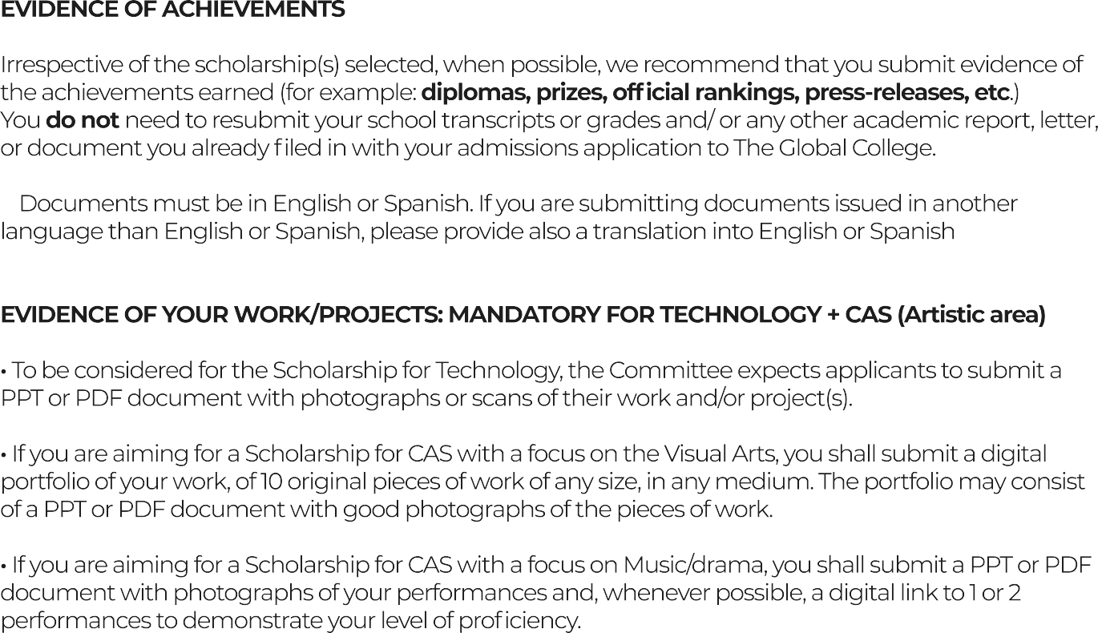

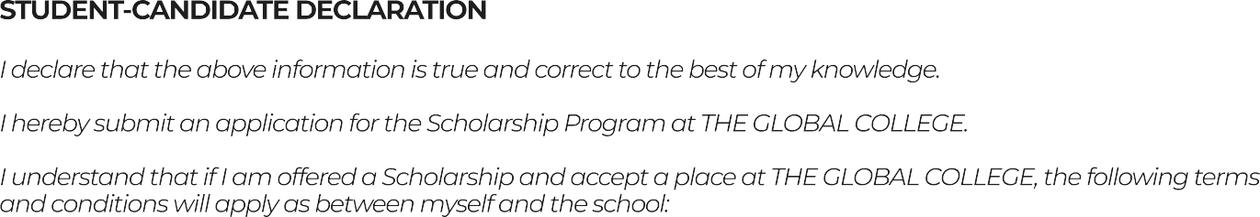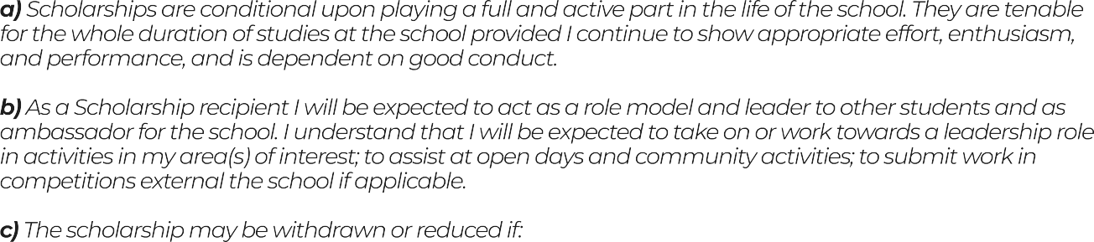

Sanvi R

01-10-2025



Raviraj R

01-10-2025

Shweta KB

01-10-2025